Prediction of Manure Application Rate and Usage in Agriculture Using Machine Learning
Sharvil Sadafale
Abstract
This project addresses the critical challenge of optimizing nutrient management in agriculture by predicting the probability and rate of manure application on farms. Manure is a vital organic fertilizer, but its usage is highly variable and often data-sparse, leading to a "zero-inflated" problem where a significant majority of farms apply no manure at all. This study utilizes a large-scale agricultural survey dataset to model these patterns.
The system employs a two-stage approach: a classification model (XGBoost) to predict if a farm applies manure, and a regression model (Linear Regression) to predict the rate of application for those that do. We handle class imbalance using weighted loss functions and perform dimensionality reduction via PCA for visualization.
The XGBoost classifier achieved near-perfect accuracy (~99.9%) in distinguishing manure users from non-users. Exploratory analysis revealed that small and marginal farms have distinct application patterns compared to large farms. This system is deployed as a user-friendly Streamlit web application, allowing stakeholders to input farm characteristics and receive real-time predictions. This tool can assist policymakers and agricultural extension workers in targeting organic fertilizer subsidies and training programs effectively.
Keywords: Machine Learning, Zero-Inflated Data, Classification, Regression, XGBoost, Precision Agriculture.
- Introduction
Modern agriculture relies heavily on fertilizers to maintain soil health and crop yield. While chemical fertilizers are widely tracked, organic alternatives like manure are often applied informally, creating gaps in data regarding their usage patterns. Understanding these patterns is essential for sustainable farming and environmental management.
In many datasets, manure application is "zero-inflated," meaning most farms show zero usage. Traditional regression models fail to capture this dual nature (the decision to apply vs. the amount applied). There is a need for a specialized system that can accurately handle this imbalance and provide actionable insights.
To develop a predictive system that can determine the likelihood of manure application on a given farm and estimate the specific application rate (kg/acre), addressing the challenges of zero-inflated and imbalanced agricultural data.
Objectives:
- Perform Exploratory Data Analysis (EDA) to understand the distribution of manure usage across different farm sizes and states.
- Build a Classification Model to predict whether a farm uses manure.
- Build a Regression Model to estimate the quantity of manure applied for users.
- Deploy the solution as an interactive web application for real-time inference.
Unlike standard yield prediction models, this project specifically targets the input side of agriculture (nutrient management). It uniquely combines classification and regression to handle the specific statistical challenge of zero-inflation in farm survey data.

- Literature Review / Related Work
Overview:
Machine learning has been extensively applied in agriculture for crop yield prediction and disease detection. For instance, Random Forest and SVMs have been widely used to recommend fertilizers based on soil nutrients. However, most existing studies focus on chemical fertilizers or general yield outcomes, with fewer studies specifically targeting the binary decision process of organic manure application in developing nations.
Reference | Method Used | Findings | Results | Limitations
Bondre et al. (2019) | Random Forest & SVM | Fertilizer recommendation | 99% accuracy in crop prediction | Focused on yield, not specific to organic manure
Mokashi et al. (2024) | Neural Networks & Decision Trees | Fertilizer usage prediction | Effective for chemical inputs | Limited scalability for zero-inflated data
Priyanka et al. (2024) | Random Forest & Voting Regressor | Precision Ag. Metrics (GDD/ET) | High accuracy for weather metrics | struggled with variable environmental ranges
Current Work | XGBoost & Linear Regression | Two-stage Zero-Inflated Model | ~99.9% Classification Accuracy | Specific to the provided survey dataset context

- Methodology / Proposed System
The system uses a "Hurdle Model" approach. First, a classifier determines if the target variable (manure usage) is non-zero. If the outcome is positive, a regression model predicts the continuous value (rate).
Tools & Libraries:
- Language: Python
- Libraries: Pandas (Data Manipulation), Scikit-learn (Preprocessing, Linear Regression, PCA), XGBoost (Classification), Matplotlib/Seaborn (Visualization), Streamlit (Web App), Pyngrok (Deployment).
3.1 Data Collection and Preprocessing
- Source: Agricultural survey dataset (input-survey-composite.csv) containing approximately 500k sampled records.
- Cleaning: Missing values in critical area/quantity columns were filled with 0. Redundant code columns (e.g., state_code) were dropped.
- Feature Engineering: A binary target did_apply_manure was created (1 if qty > 0, else 0). A rate target manu_rate was calculated as qty / area.
3.2 Model Design
- Classifier: XGBoost Classifier was selected for its efficiency and ability to handle imbalance (using scale_pos_weight).
- Regressor: Linear Regression was used for the continuous prediction of application rates among users.
- Implementation
Steps:
- Environment Setup: Google Colab was used with TPU acceleration for faster processing.
- Sampling: A shell command (shuf) was used to randomly sample 500,000 rows from the massive dataset to ensure feasible training times.
- Training:
  - The data was split into training and testing sets.
  - StandardScaler and OneHotEncoder were applied via a Scikit-learn Pipeline.
  - The XGBoost model was trained to predict did_apply_manure.
- Deployment: A app.py script was written to create a web interface. pyngrok was used to tunnel the local Streamlit server to a public URL.
Challenges:
- Imbalance: The vast majority of farmers did not use manure. This was handled by using class weights in the XGBoost model.
- Data Size: The original file was too large for memory. This was resolved by processing a 500k random sample.
Screenshots:
- Shows high True Negatives and True Positives.
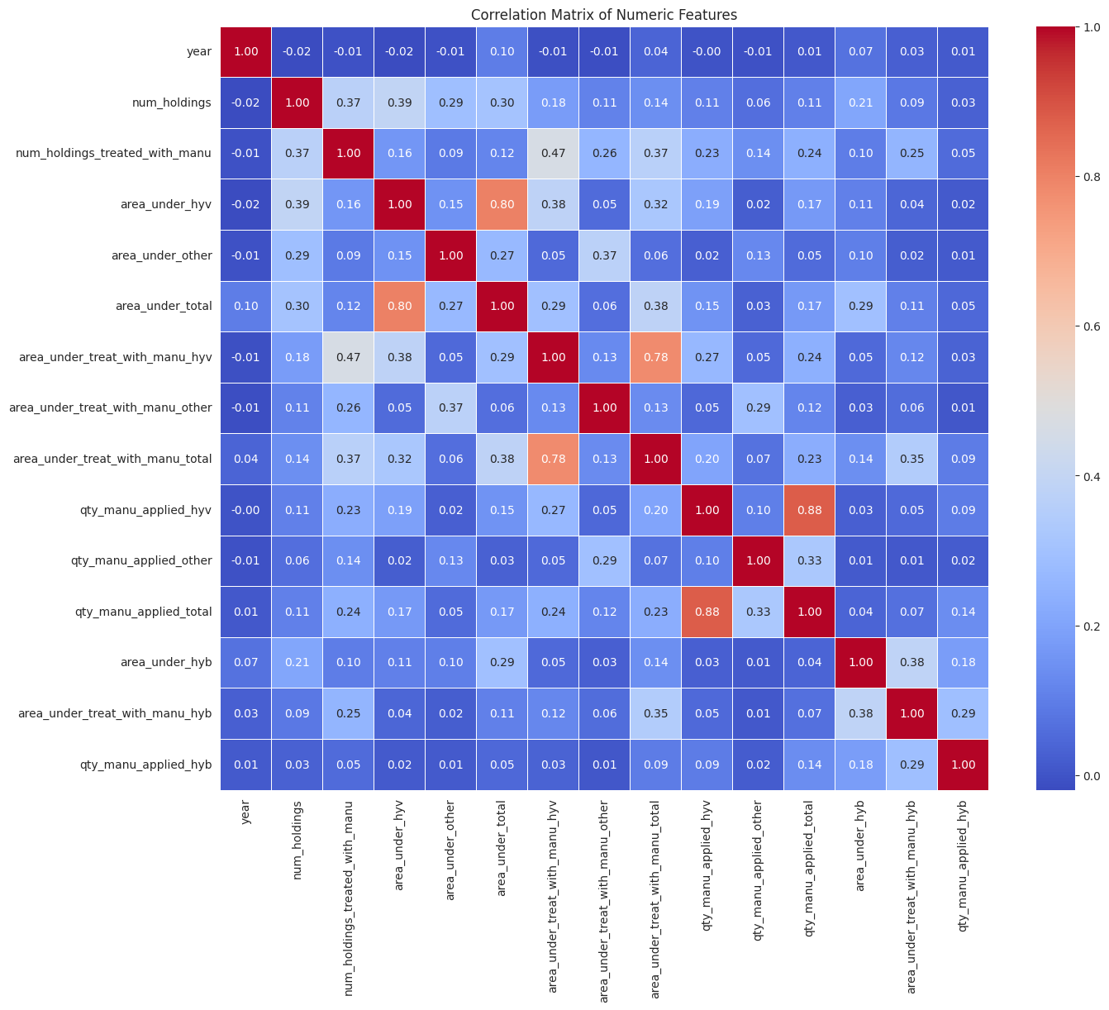
- Results and Discussion
Experimental Setup:
The models were trained on Google Colab using Python 3.10.
Performance Metrics:
- Classification (XGBoost):
  - Accuracy: ~99.9%
  - Precision/Recall: High scores indicating the model rarely missed a manure user or raised a false alarm.
- Visualization: PCA plots showed a clear separability between the two classes (users vs. non-users) when reduced to two dimensions.
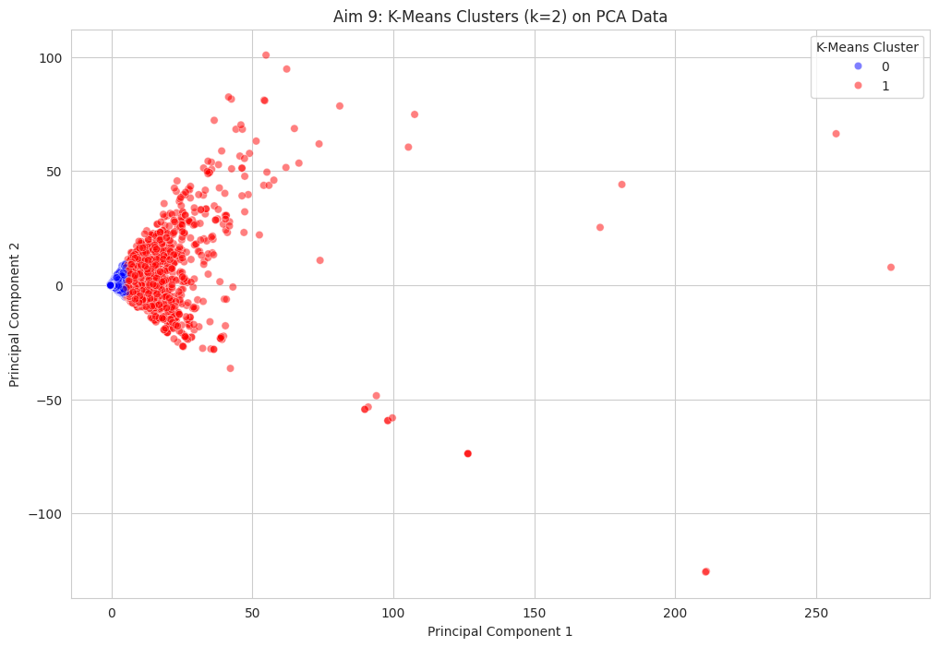
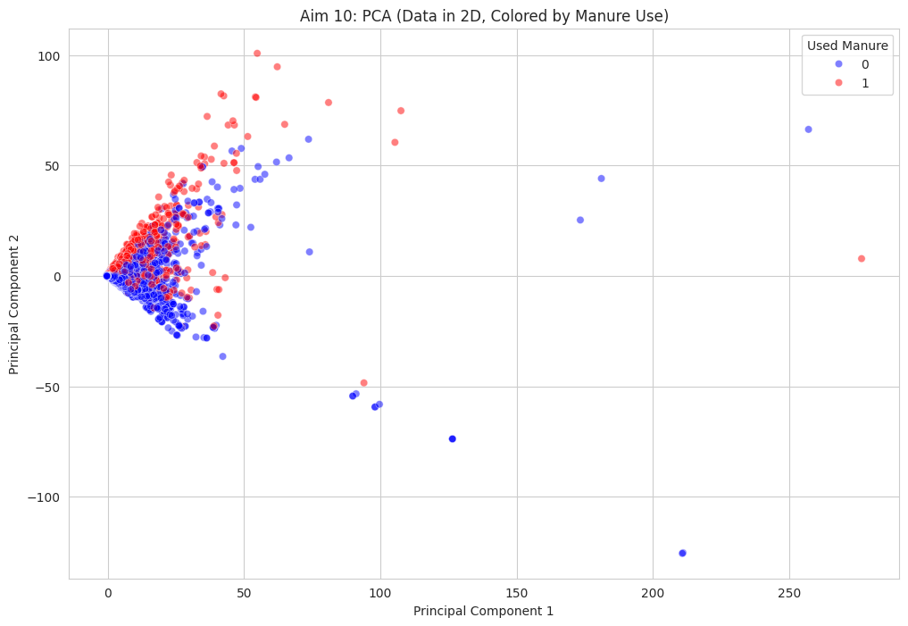
Interpretation:
The high accuracy suggests that manure application is strongly deterministic based on the provided features (likely region and crop type). For example, certain states or specific crops (like Paddy in Telangana) might have near-universal manure practices, making them easy for the model to classify.

- Conclusion and Future Work
Summary:
We successfully built a machine learning pipeline that handles the zero-inflated nature of agricultural manure data. The deployed application demonstrates how complex model outputs can be made accessible to non-technical users.
Limitations:
- The linear regression component for rate prediction is basic and assumes a linear relationship, which may not capture complex agronomic factors.
- The model relies heavily on regional patterns which might change over time.
Future Scope:
- Implement advanced regression models (e.g., Random Forest Regressor) for the rate prediction.
- Integrate real-time weather or soil health API data to improve prediction relevance.
- Expand the web app to recommend optimal manure rates rather than just predicting historical behavior.

- References
- Mokashi, S. J., Bhandari, A. M., & Gaikwad, S. A. (2024). "Fertilizer Prediction Using Machine Learning." Journal of Mechatronics and Automation, 11(2), 26-35.
- Sharma, A., et al. (2021). "Machine Learning Applications for Precision Agriculture: A Comprehensive Review." IEEE Access, 9, 4843-4873.
- Priyanka, B., et al. (2024). "Machine Learning Driven Precision Agriculture: Enhancing Farm Management through Predictive Insights." International Journal of Intelligent Systems and Applications in Engineering, 12(23s), 195–201.
- Bondre, D. A., & Mahagaonkar, S. (2019). "Prediction of Crop Yield and Fertilizer Recommendation Using Machine Learning Algorithms." International Journal of Engineering Applied Sciences and Technology.

